**GPU Enhanced LIDAR for Real Time 3D Sensing**

|  |
| --- |
| A Project Report Presented to  The Faculty of the College of Engineering |
| San Jose State University In Partial Fulfillment Of the Requirements for the Degree **Master of Science in Computer Engineering** |

|  |
| --- |
| By |
| Agrawal Urvashi, Naphade Bhupendra, Pachore Amit Vasant, Shankar Anush |
| May, 2017 |

|  |
| --- |
| Copyright © 2017 |
| Agrawal Urvashi, Naphade Bhupendra, Pachore Amit Vasant, Shankar Anush |
| ALL RIGHTS RESERVED |

|  |
| --- |
| APPROVED |
|  |
| Li Harry, Project Advisor |

**aBstract**

GPU Enhanced LIDAR for Real time 3D sensing

By Agrawal Urvashi, Naphade Bhupendra, Pachore Amit Vasant, Shankar Anush

Three-dimensional environment sensing and imaging are an integral part of autonomous vehicle, computer vision and machine learning technologies. Existing sensing techniques include Light Detection and Ranging (LIDAR), Image Processing using digital camera and Radio Detection and Ranging (RADAR). LIDARs with image processing capability poses challenge of increased cost, short sensing distance and meager additional features. Thus, there is need for cost reduction, enhancement in distance sensing and addition of features to the existing LIDAR.

The project aims at hardware and software design for the LIDAR using powerful OpenCV, OpenGL, CUDA and Embedded C programming techniques and algorithms embedded onto the NVIDIA Jetson TK1 development board. The board is equipped with a fast Arm A15 CPU and NVIDIA Kepler GPU with 192 CUDA cores. GPUs are the current state of the art processors which are used in accelerated computing for scientific, engineering, analytics etc. applications. GPU offers unprecedented computing by carrying out compute intensive tasks in an extremely fast and parallel manner and saving the CPU for the sequential tasks.

In this project, we will design a LIDAR with increased sensing distance and added feature of Augmented Reality integration with camera feed. The prototype LIDAR will be able to sense up-to 10-20m as compared to existing LIDAR which can measure only up-to 6m. The outcome will be enhanced 3D environment sensing LIDAR prototype which can be integrated in self-driving vehicles for real-time sensing of the environment and taking better driving decisions.

|  |
| --- |
| Acknowledgments |
| The authors are thankful to Professor Harry Li for his invaluable comments and assistance in the preparation of this study. |

Table of Contents

Chapter 1. Project Overview 1

Introduction 1

Laser Triangulator 2

Structured Light 2

Stereo Vision 2

Photogrammetry 2

Time of Flight 2

Interferometry 3

Proposed Areas of Study and Academic Contribution 4

Embedded Systems 4

Image Processing and computer graphics 4

Current State of the Art 5

Chapter 2. Project Architecture 7

Introduction 7

Hardware Architecture 8

Jetson TK1 Hardware Architecture 8

DC Motor 9

Photo micro sensor 9

LIDAR 9

LPC 1769 Controller 9

USB Camera 10

Software Architecture 10

OpenCV 10

CUDA 10

Glossary 12

References 13

Appendices 15

Appendix A. Description of Implementation Repository 15

List of Figures

Figure 1: Project Architecture 7

Figure 2: Jetson TK1 block diagram 9

Figure 3: Software Architecture 11

Figure 4: Proposed User Interface Design 12

List of Tables

# Project Overview

## Introduction

In recent years’ three-dimensional environment sensing and imaging has seen tremendous growth and has been adopted in various applications. It is an integral part of autonomous vehicle, computer vision, robotics and machine learning technologies. It is used in these real-world applications with great precision and success. The technology has undergone extensive research to improve existing sensing techniques and develop efficient algorithms.

3D environment sensing technology deals with scanning the environment and creating a three-dimensional map of it. Sensing and imaging involves an energy emission source and a detector unit. Multiple energy emission sources such as flash lamp, laser, microwave, ultrasonic waves, pulse modulator, sun light, radio waves etc. can be used based on intended applications.

Similarly, multiple detector units can be used, such as camera, shutter systems, laser detector etc. While the emission source bombards objects with energy, the detector unit receives and analyzes reflected emissions. Based on the analysis of received energy, distance of an object in the environment can be determined. Buffers are used to store the sum and differences extracted from the received beam, to calculate the distance of an object from the sensing unit (Medina, 1992).

While several methods exist for sensing, non-optical and optical sensing are the two extensively used methods. While non-optical sensing method uses acoustic and electromagnetic energy, optical sensing systems use light as a source for environment sensing. Optical 3D imaging techniques include laser triangulators, structured light, stereo vision, photogrammetry, time of flight, interferometry etc. (Sansoni, Trebeschi, & Docchio, 2009). In this section, we review the various techniques used for 3D sensing and mapping.

### Laser Triangulator

Triangulation is the most widely used technique for sensing in a short range of up to 10 meters. Most triangulators detect objects between 0.5m to 2m precisely. By analyzing the triangular geometry between the source, object and the detector, distance of the object from the sensor can be determined. This method is accurate, relatively insensitive to lighting conditions and can produce texture effects.

### Structured Light

This technique is similar to the Laser Triangulator. In this method, bi-dimensional patterns of non-coherent light are simultaneously projected by structured light sensors to determine the range of the single observed point.

### Stereo Vision

Stereo Vision is a passive method involving simultaneous image capture using two cameras. The technique involves camera modelling, feature extraction, corresponding analysis and triangulation to determine object distance. In certain applications, a single camera may be seen taking images from six different angles. The major challenge in this technique is determining the common point between the two camera images.

### Photogrammetry

Photogrammetry is used to create 3D models using multiple images. The process involves camera calibration and orientation, image point measurements, 3D point cloud generation, surface generation and texture mapping to determine object distance from sensor. The major advantage of this technique is its ability to extract information from images of moving objects.

### Time of Flight

Time of Flight method measures the time required for a light wave to travel from source to a distant object and back to the detection unit. The intensity of the reflected signal along with the time of flight is used to generate 3D data points and calculate distance of the object. Due to excessive scattering of light during reflection, the technique is inaccurate and offers low precision.

### Interferometry

This technique uses light interference to determine the distance of an object around the sensor. A beam splitter is used to split light, which is later recombined. Based on the spatial shape of the combined beam, distance of the object is calculated.

While Incoherent sources of light are easily controllable and cost effective, brightness of is one of the major concerns. Laser sources provide unique advantages in 3D environment sensing due to “directional, bright and spatially coherent light (Beraldin et al., 2003)”. A powerful and safe to use laser source in the Infrared frequency band coupled with time of flight sensing technique, helps create a robust environment sensing device.

A LIDAR or Light detection and ranging is an environment sensing device designed with the idea mentioned above. “With the development of High quality and inexpensive digital cameras, 3D environment sensing and mapping technology has grown beyond proportion (Tu, 2009)”. Manipulation of images using platforms like OpenCV has led to low cost solutions, capable of being deployment in real world applications with great ease. But the lack of optimization in open source image processing API’s has left the approach stagnant. This can be attributed to lack to control over run time, resource and other optimizations for the implementations. Laser based sensing presently seems to have a bright and prospective future.

Combined with High quality camera feed and other systems LIDAR technology has dominated several application domains. “Urban challenge is one such upcoming application and LIDAR is used to provide data on the surrounding environment for obstacle avoidance and mapping (Hsu, Hsu & Chang, 2012).”

## Proposed Areas of Study and Academic Contribution

The proposed project deals with the design and implementation of a LIDAR with Augmented reality, for environment sensing applications. The project requires knowledge of Embedded software development, Embedded hardware, computer graphics, image processing, embedded serial communication protocols such as Modbus and I2C, client server models, basic system interfaces etc. The major areas that would be studied and understood to design and implement the proposal are as follows:

### Embedded Systems

This deals with the design and implementation of hardware and software required for the proposal to perform its intended task. Embedded system is a hardware system controlled using software instructions. Detailed knowledge of microcontrollers, programming microcontrollers, controller interfaces, usage of controller peripherals, optimization of embedded code, testing and debugging methods is necessary for the success of this project. A thorough understanding of software development lifecycle, programming languages, programming techniques, interfacing sensors and actuators to controllers, controlling internal and external peripherals will help achieve good quality results with the proposed design. These learnings would account for the academic contribution of the project.

### Image Processing and computer graphics

Processing or manipulating images to extract information from it, or utilize it for intended application is the sole purpose of image processing. This domain also involves video processing and graphics generation. An understanding of characteristics of pixels, ways to modify them and creation of pixels with desired properties are important learnings from the project.

The proposed project is an important one due to the fact the project covers major topics in embedded hardware design and embedded software development combined with the image processing and computer graphics. The project aims to improve state of the art technology with the use of efficient algorithms, quality hardware, best software optimizations and industry best practices in software development. The project also adds new features which would improve user experience, provide a standalone system for deployment and eliminate drawbacks in existing design.

It provides an opportunity to work with state of the art technology in embedded system and environment sensing, to design and develop algorithms for graphic generation, processing images and augmented reality. The proposal has applications in several remarkable technologies like robotics, computer vision, self-driving vehicles and machine learning, therefore is extremely important for the success of these technologies. With the proposed ideas, the applications are bound to perform efficiently, thereby paving the way for further research and better products.

## Current State of the Art

The focus of our project is on 3D sensing using LIDAR, with added feature of augmented reality. A LIDAR emits laser light on a distant object and determines the distance to the object. 3D images can be generated based on data collected by the LIDAR. Another aspect of 3D sensing is area measurement, which involves scanning surrounding area for data acquisition. It can be done with multiple techniques involving mechanical displacement, Multi-point and line projection, Fringe and coded pattern projection and Moiré effect (Beraldin et al., 2003). Multiple 3D imaging techniques have been reviewed as a part of literature survey. Different sensing techniques are used for different application areas.

Current State of the art in LIDAR sensing includes scanning imaging LIDAR, MEMS scanner based LIDAR (Lee et al., 2016) and pulsed floodlight illumination imaging LIDAR technique. MEMS scanner based technique uses a 2-axis scanner to determine the distance of the obstacle from the LIDAR (Lee et al., 2016). Detection range is the major limitation of these techniques. The prominent area of research in 3D sensing involves optimal extraction and analysis of data to generate 3D maps. The data retrieved from the light or imaging systems needs to be processed with high accuracy and in real time. GPU is the new cutting edge technology capable of handling real time data without delay. With state of the art programing model using CUDA, parallel execution of tasks on GPU cores can be improved. This allows faster response, higher data and frame rates and highly accurate results. Our design uses Jetson TK1 GPU module with a business grade camera for 3D modelling which would involve Depth-map Retrieval. Our project aims to work with state of the art technologies, thereby improving existing LIDAR design, eliminating drawbacks and providing accurate results.

# Project Architecture

## Introduction

Current sensing systems include RADAR and Laser ranging technologies. There are several limitations and constraints in usage of such system with respect to the cost, range and the data rate. 3D mapping and sensing of the environment is a prominent research area in the automotive industry today for the successful navigation of the Self Driving car. This chapter will provide details on the architecture for the proposed design of GPU based LIDAR system that is aimed to improve enhance range at a low cost.

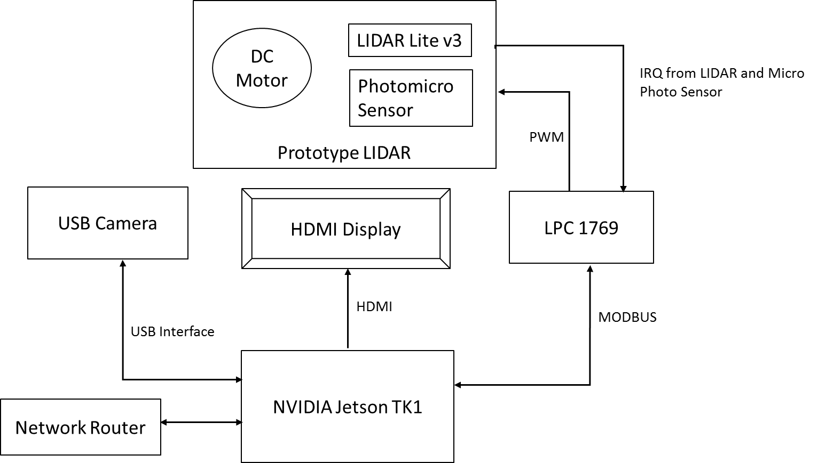

Figure : Project Architecture

The LiDAR is a device that can be used to sense the objects around us. However, it cannot give the exact details of the object. A camera acts as the vision of the car and helps the car to capture the objects. A combination of the two can help the car map the object and detect the exact distance. The image captured by the camera requires heavy image processing which can be handled only by a GPU. Hence, we chose the NVIDIA TK1 as our platform. On the Jetson TK1, we will interface the camera, DC motor and the laser pointer. The LIDAR will be rotated in 360 degrees with the help of the DC motor. In addition, the intersection point of the laser source with the image taken by the camera will help in measuring the distance of the object from the camera. This chapter describes the hardware and the software, which we are going to use to implement the project.

## Hardware Architecture

The prime focus of the project design are as follows

* Provide end user a low-cost alternative to the existing sensing systems
* Enhance sensing distance up to 40m as compared to 6m for available systems
* Provide augmented reality feature for improved user interface.

Considering the project objectives, we have planned to design a rotating assembly for the prototype LIDAR communicating with the LPC 1769 controller. NVIDIA Jetson TK1 board used to process the images form the camera at the required speed. The architecture for the project is shown in figure 1.

### Jetson TK1 Hardware Architecture

The project will be implemented on the NVIDIA TK1 platform. The board is embedded with an on-board NVIDIA Kepler Graphic Processing Unit(GPU) and has all the peripheral support required for the successful execution of the project. GPUs are the state of the art parallel processors which can deliver 100s GFLOPS of performance. The GPUs offload the CPU from compute intensive tasks and hence leave more bandwidth on the CPU for the sequential processing. The major difference between a CPU and a GPU is that the CPU consists a couple of cores with a complex pipelined structure. The CPU has branch prediction and out of order execution, while a GPU has a relatively simple structure but is powered by hundreds of cores. The TK1 Kepler GPU consists of 192 such cores and can provide 300GFLOPS of 32-bit floating point computations.

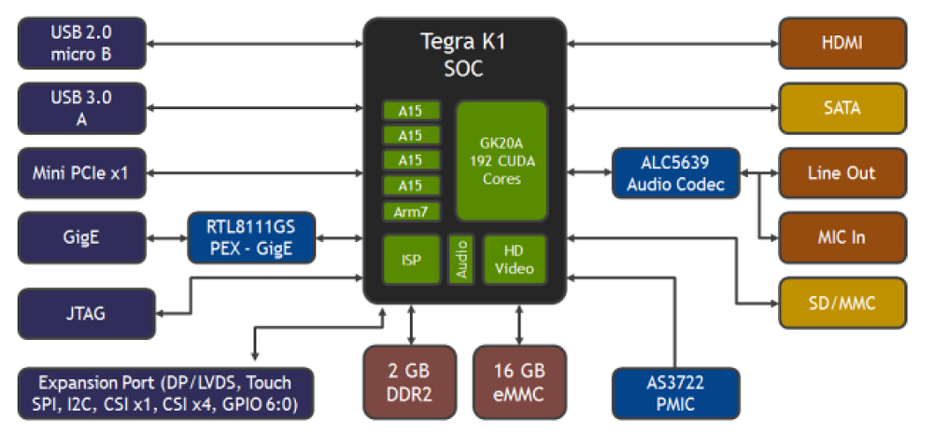

Figure 2: Jetson TK1 block diagram (Brown, 2014)

### DC Motor

The DC motor we are using is a low rpm motor. The motor dimensions are 18mm x 24mm and is suitable for the rotating assembly. The motor works on 3-5V DC. The motor will be rotated at 10Hz with 30-40 rpm.

### Photo micro sensor

The rotation of the disc will be monitored using a photo micro sensor. We are using SX672 sensor from Omron. This sensor has a slot of 5 mm.

### LIDAR

The LIDAR must give a consistent reading for detection range 20m and above. To achieve this range consistency, we have come up with LIDAR Lite v3 from sparksfun. This module is easy to interface and gives stable readings up to 40m.

### LPC 1769 Controller

To avoid processing load on Jetson board we are using NXP’s LPC 1769 controller to control the rotating assembly and get the LIDAR readings. This controller has an ARM Cortex- M3 microcontroller. The board has 64 kB SRAM, 512 kB Flash, 4xUART, 3xI2C, SPI, 2xSSP, 2xCAN, PWM, USB 2.0 Device/Host/OTG, RTC, Ethernet, I2S and good debugging capabilities.

### USB Camera

This is an industry grade high resolution USB camera that can be plugged in to the Jetson board. The camera used for our project will be Logitech C930e. This camera can deliver 1080p HD video at 30 fps with 90-degree extended view and 4X zoom.

## Software Architecture

The software package that will be delivered along with the prototype model should be open source and easy to integrate with other systems. LPC controller will be programmed using C/C++ to configure and monitor the LIDAR and the DC motor. OpenCV will be used for image processing and CUDA will be used to give the code the capability to process in parallel on the GPU.

### OpenCV

Open Source Computer Vision(OpenCV) is a library available in C/C++/Python useful for real-time computer vision. It has a range of inbuilt APIs which can be used for image/video capturing and processing. Motion understanding, object detection, facial recognition systems etc. are some of the fields where OpenCV is widely used.

### CUDA

CUDA is a parallel computing platform and has an API model created by NVIDIA. It is used for general carrying out purpose computations on the GPU. CUDA gives the complete freedom to the developer to choose the memory region on the GPU on which he wants to store his data. This makes the computations faster and flexible. OpenCV contains a GPU module that contains the CUDA APIs for the GPU. With this module, it can accelerate almost all the APIs of the OpenCV. The code we will write in OpenCV can be made to run on the GPU with these APIs resulting in faster image processing and better performance.

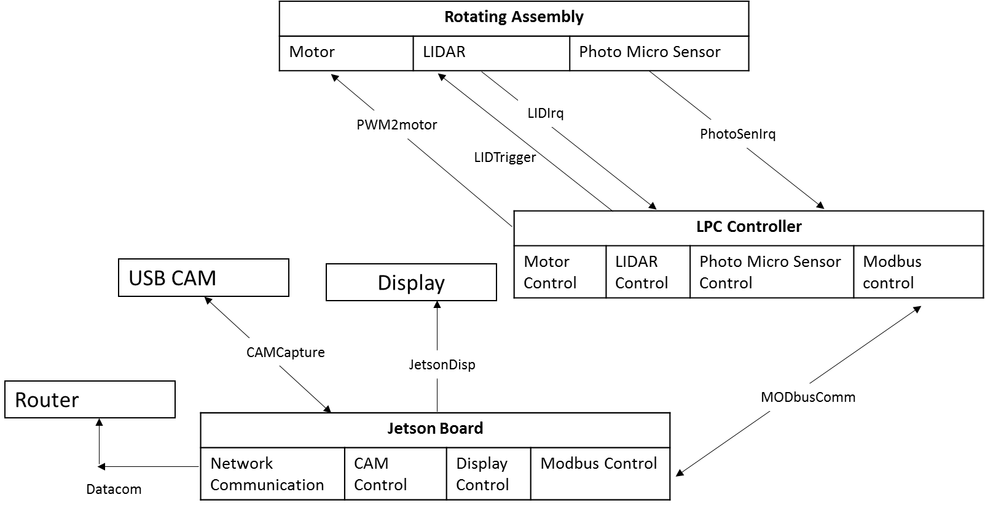

Figure : Software Architecture

The software developed for the project will include several libraries communicating with the hardware and intercommunication with each other for data acquisition and processing. Figure 3 shows the software architecture of the project. The signal names are the proposed library names for the control and data functions that will be developed.

The data captured will be accessible from below mentioned interface

**Graphical User Interface**

Graphical user interface is further divided in four different parts. First one is Augmented feed section. In this section, a live video feed from the camera embedded with LIDAR distance data will be displayed. This gives the user visually mapped object distances. We can separate remaining sections as the debug windows. These are Connected Devices, H/W Module Status and the Console. Connected devices sections will be displaying the IP addresses of all the connected devices. H/W module status window act as feedback to know if different parts of the devices are functioning properly. Console window provides the application software status.

With proposed plan, we will be using OpenCV and OpenGL APIs to design the above proposed GUI application.

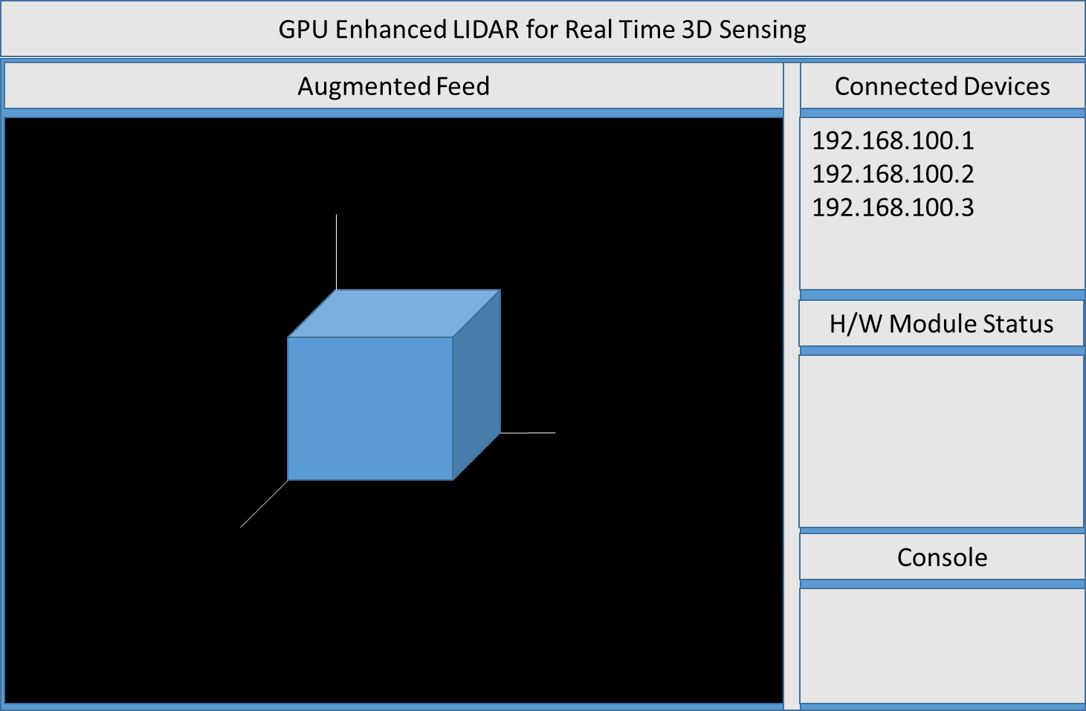

Figure : Proposed User Interface Design

**Ethernet Interface**

This interface gives ability to connect with other devices. Using TCP client server program device can be configured to send data over the network. C/C++ has the socket APIs which will be used to add this ability.

Glossary

The table below summarizes the frequently used terms in our project.

|  |  |
| --- | --- |
| Term | Meaning |
| CUDA | Computer Unified Device Architecture is a parallel programming model. |
| LIDAR | Laser detection and Ranging is a device capable of sensing the environment around it. |
| GPU | Graphics Processing Unit is electronic circuit that can rapidly manipulate and alter memory to accelerate processing. |
| 3D | Three-Dimensional space consists of length, width and height. |
| MEMS | Micro-electro Mechanical Systems is a technology that combines computers with tiny mechanical devices on semiconductor |
| OpenCV | Open Computer Vision is an open source computer vision library. |

References

1. Medina, A. (1992). *U.S. Patent No. 5,081,530*. Washington, DC: U.S. Patent and Trademark Office.

2. Sansoni, G., Trebeschi, M., & Docchio, F. (2009). “State-of-The-Art and Applications of 3D Imaging Sensors in Industry, Cultural Heritage, Medicine, and Criminal Investigation”. *Sensors (Basel, Switzerland)*, *9*(1), 568–601. http://doi.org/10.3390/s90100568

3. Beraldin, J. A., Blais, F., Cournoyer, L., Godin, G., Rioux, M., & Taylor, J. (2003). “Active 3D sensing”.

4. Tu, X. (2009). *Image based 3D Sensing and Modeling Technology for High-end Digital Cameras* (Doctoral dissertation, Stony Brook University).

5. Hsu, C. W., Hsu, T. H., & Chang, K. J. (2012). “Implementation of car-following system using LiDAR detection”. *2012 12th International Conference on ITS Telecommunications*. doi:10.1109/itst.2012.6425157

6. Lee, S. W., Jeong, S. W., Lee, S. K., Kim, Y. K., & Park, J. H., (2016). “LIDAR system using indirect time of flight method and MEMS scanner for distance measurement”. Paper presented at the *2016 International Conference on Optical MEMS and Nanophotonics (OMN),*1-2. doi:10.1109/OMN.2016.7565894

7. Li, H., (1992). “Three-dimensional computer graphics using EGA or VGA card”. *IEEE Transactions on Education*, vol. 35, no. 1, pp. 44-49, Feb 1992. doi: 10.1109/13.123416.

8. Eric Brown. (2014) Jetson TK1 block diagram [Online Image].

Retrieved Mar 25, 2014 from <http://hackerboards.com/nvidia-jetson-tk1-most-advanced-hacker-sbc/>

Appendices

* 1. Description of Implementation Repository